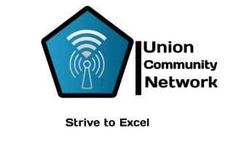

Kalobeyei Village 1
Contact: +254 757 143 720
Email: unioncommunitynet@gmail.com

CLIENT:

Att: Youth Voices Community
Off Spine Road , House 1941
Nasra gardens gate C, Nairobi.
Contact: +254 720 808 217

Quote 20/2025

Description | Unit | Rate /day | Amount in KSH
Project LLEARN:  Videography and Photography Services.  Output: 1 summary video, 3 short interviews shot and edited, 40-50 high-resolution photographs shared on google drive | 3 days | 11,969.50/ Day | 35,907.60
Withholding tax of 5% |  |  | 1,889.90
Total |  |  | 37,797.50

Accounts payable in favour of :

Mpesa number: 254 757 143 720 Benard Wasike

